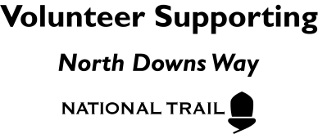

North Downs Way Ambassadors Risk Assessment

For the safety of all of the people on your event, it is important that you should complete a risk assessment for each event you lead. It is hoped that this form will make the process as easy as possible. Simply tick the boxes that apply and fill in any extra information as you see fit. There is also extra space to add additional hazards specific to your walk.

Walk name: Leader: Date:

HAZARD | RISK | WHO | PRESENT | CONTROL | LOCAL COMMENTS
Slips, trips and falls | Cuts, bruises, broken limbs | All |  | Wear sturdy shoes. Take care when crossing rough ground
Environment | Sunburn, hypothermia, exhaustion | All |  | Avoid walks in extreme temperatures. Take suitable clothing. Advise participants to bring water
Wildlife (bites, stings, poisonous plants) | Sickness, anaphylactic reaction etc. | All |  | Warn participants about potential bites and stings and not to eat plants unless they are certain what it is.
Roads and other traffic (including illegal use of footpaths) | Collisions with traffic | All |  | Cross roads as a group in a safe place. Warn participants of the possibility of off-road vehicles using the route.
Human factors | Assault | All |  | Avoid confrontation if possible. Carry mobile phone. Leave nobody isolated
Isolated walker | Getting lost, vulnerable to attack/accident | All |  | Leave no walker isolated. Use a back marker if numbers are high
Livestock and other animals | Bites, collisions and other attacks | All |  | Beware of livestock, avoid if necessary
Unsuitable clothing and footwear | Increased risk of slips and trips as well as heat stroke/hypothermia | All |  | Inform all participants to wear sturdy footwear and bring enough clothes for changeable conditions
Vulnerable participants (e.g. young people, adults with learning difficulties) | Potentially less aware of risks than other groups | All |  | Consider smaller groups or accompanied walkers only. Use less risk routes.

LOCAL HAZARDS SPECIFIC TO YOUR WALK

